Production and characterization of surfactin-like biosurfactant produced by novel strain Bacillus nealsonii S2MT and it's potential for oil contaminated soil remediation
Irfan Ali Phulpoto¹, Zhisheng Yu ^{1 *}, Hu Bowen ¹, Fabrice Ndayisenga ¹, Li Jinmei¹, Hongxia Liang¹, and Muneer Ahmed Qazi²

¹College of Resources and Environment, University of Chinese Academy of Sciences, 19 A Yuquan Road, Beijing 100049, P.R. China

²Institute of Microbiology, Faculty of Natural Science, Shah Abdul Latif University, Khairpur Mir's - 66020, Sindh, Pakistan.

*Corresponding Author(s):
Prof. Dr. Zhisheng YU
College of Resources and Environment, University of Chinese Academy of Science, 19 A Yuquan Road, Beijing 100049, P.R. China
Email: yuzs@ucas.ac.cn
Supplementary Information
9 Pages including cover page
6 Figures
3 Tables

Figure S1. Culture morphology of isolated strain S2MT (Bacillus nealsonii) (a), TEM image of strain (b), and TEM image during biosurfactant production, red arrow indicates the extracellular biomass produced by isolated strain (c). Potential of biosurfactant in oil displacement activity (d), drop collapse activity (e), and emulsification activity (f).

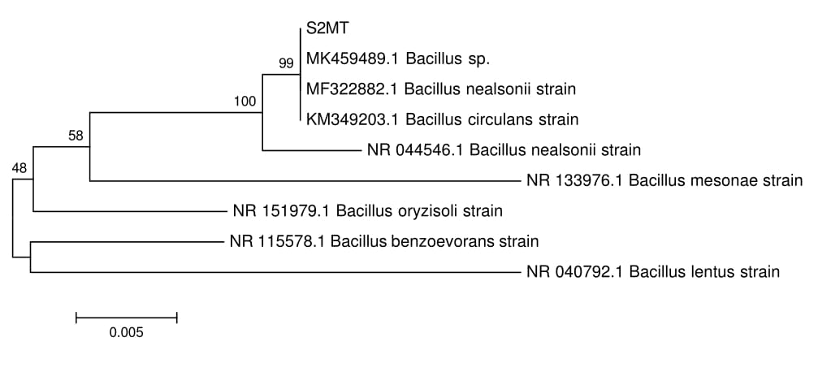
Figure S2. Phylogenetic analysis of isolated strain S2MT with closely related taxa.

Figure S3. Optimization profile of strain B. nealsonii S2MT for various carbon and nitrogen sources for product recovery (a-i).

Figure S4. Percent contribution of normal probability chart, and Pareto chart indicates the rank wise positive and negative effects factors on biosurfactant production based on model (a &b). While the interaction between the factors such as temperature vs pH (c), temperature vs NaCl (d), and pH vs NaCl (e).
Figure S5. Significant effects of individual factors i.e. temperature, pH, agitation, NH₄NO₃, yeast extract and NaCl conc. (a- f) respectively, on biosurfactant production yield according to model terms.

Figure S6. Thin-layer chromatography analysis of lipopeptide biosurfactant. Various reagents were applied to detect the color development figure (a) and the spots were also detect in UV figure (b).

Table S1. Effect of environmental factors (temperature, pH and NaCl concentrations) on (40mg/L) crude biosurfactant production by determining surface tension measurement.
Temperature (⁰C) | Surface tension (mN/m) | pH | Surface tension (mN/m) | NaCl conc. (%) (w/v) | Surface tension (mN/m)
4 | 44.2±2.5 | 3 | 40.85±0.4 | 1 | 39.15±2.9
30 | 36.5±0.6 | 6 | 36.7±0.4 | 3 | 37.6±0.6
50 | 31.9±0.3 | 7 | 38.4±3.5 | 5 | 38.25±0.5
100 | 31.5±0.1 | 8 | 39.35±1.6 | 7 | 38.4±0.4
121 | 31.55±0.4 | 10 | 39.65±1.1 | 9 | 39.65±0.6

Table S2. Molecular mass study of lipopeptide biosurfactants of Bacillus nealsonii (S2MT) by LC-ESI/MS.
S.NO | Obtained mass (m/z) | Retention time (min) | Family | Assignment
1 | 1008.76 | 12.48 | Surfactin like | C13 [M⁺H]⁺
2 | 1030.74 | 12.48 | - | C13 [M⁺Na]⁺
3 | 1022.78 | 14.26 | - | C14 [M⁺H]⁺
4 | 1044.76 | 14.26 | - | C14 [M⁺Na]⁺
5 | 1036.78 | 15.70 | - | C15 [M⁺H]⁺
6 | 1058.77 | 15.70 | - | C15 [M⁺Na]⁺

Table 3. ANOVA table of the selected regular two-level factorial model designed for SFT (mN/m) reduction and product yield under laboratory settings.
 |  |  | SFT (mN/m) |  |  |  |  |  | Product Yield
Source | Sum of Squares | df | Mean Square | F-value | p-value |  | Sum of Squares | df | Mean Square | F-value | p-value
Model | 908.12 | 11 | 82.56 | 7.83 | 0.0036 | * | 2.141E+06 | 6 | 3.568E+05 | 5.80 | 0.0039 | *
A-Temperature | 42.58 | 1 | 42.58 | 4.04 | 0.0793 | NS | 2585.72 | 1 | 2585.72 | 0.0420 | 0.8408 | NS
B-pH | 189.75 | 1 | 189.75 | 18.00 | 0.0028 | * | 7.282E+05 | 1 | 7.282E+05 | 11.83 | 0.0044 | *
C-Agitation | 40.64 | 1 | 40.64 | 3.86 | 0.0852 | NS | 44.22 | 1 | 44.22 | 0.0007 | 0.9790 | NS
D-NH4NO3 | 15.02 | 1 | 15.02 | 1.42 | 0.2668 | NS | 1.284E+06 | 1 | 1.284E+06 | 20.87 | 0.0005 | **
E-Yeast Extract | 164.48 | 1 | 164.48 | 15.61 | 0.0042 | * | 434.72 | 1 | 434.72 | 0.0071 | 0.9343 | NS
F-NaCl | 70.98 | 1 | 70.98 | 6.73 | 0.0319 | * | 1.249E+05 | 1 | 1.249E+05 | 2.03 | 0.1779 | NS
Residual | 84.32 | 8 | 10.54 | ----- | ------- | --- | 8.000E+05 | 13 | 61537.67 | ------ | ------- | ----
Lack of Fit | 83.95 | 5 | 16.79 | 137.07 | 0.0010 | ** | 7.979E+05 | 10 | 79791.46 | 115.36 | 0.0012 | **
Pure Error | 0.3675 | 3 | 0.1225 | ------- | ------ | --- | 2075.00 | 3 | 691.67 | ----- | -----
Cor Total | 992.44 | 19 | ------ | ------- | ------- | --- | 2.941E+06 | 19 | ------ | ------- | ------- | ----
Notes: df = degree of freedom; Significance level: ** = highly significant (p < 0.001), * = significant (p < 0.05), NS = non-significant (p > 0.05)

